**Name :** Veekshitha Naragani

**Reg no :** 21BCE8943

**Task - 14/9/23**

**Getting ip address of metaspoitable :**

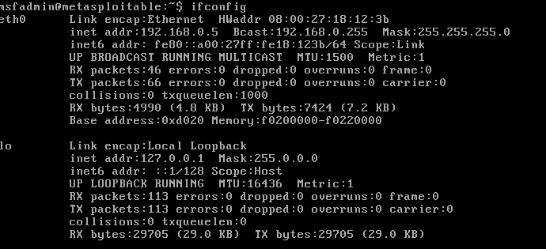

**Scan :**

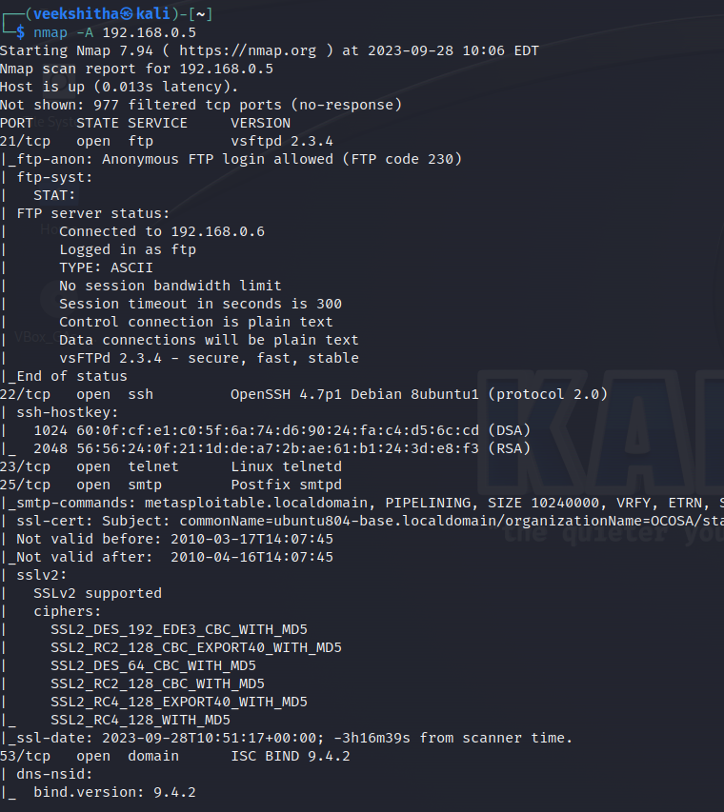

**Launching msfconsole :**

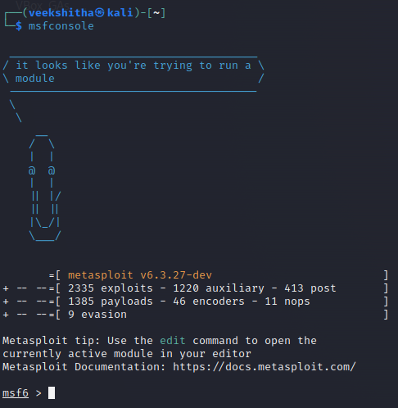

**1)Shellshock Vulnerability :**

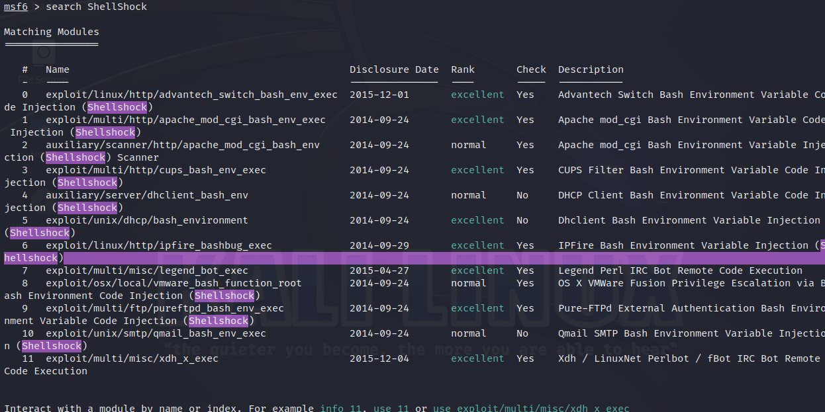

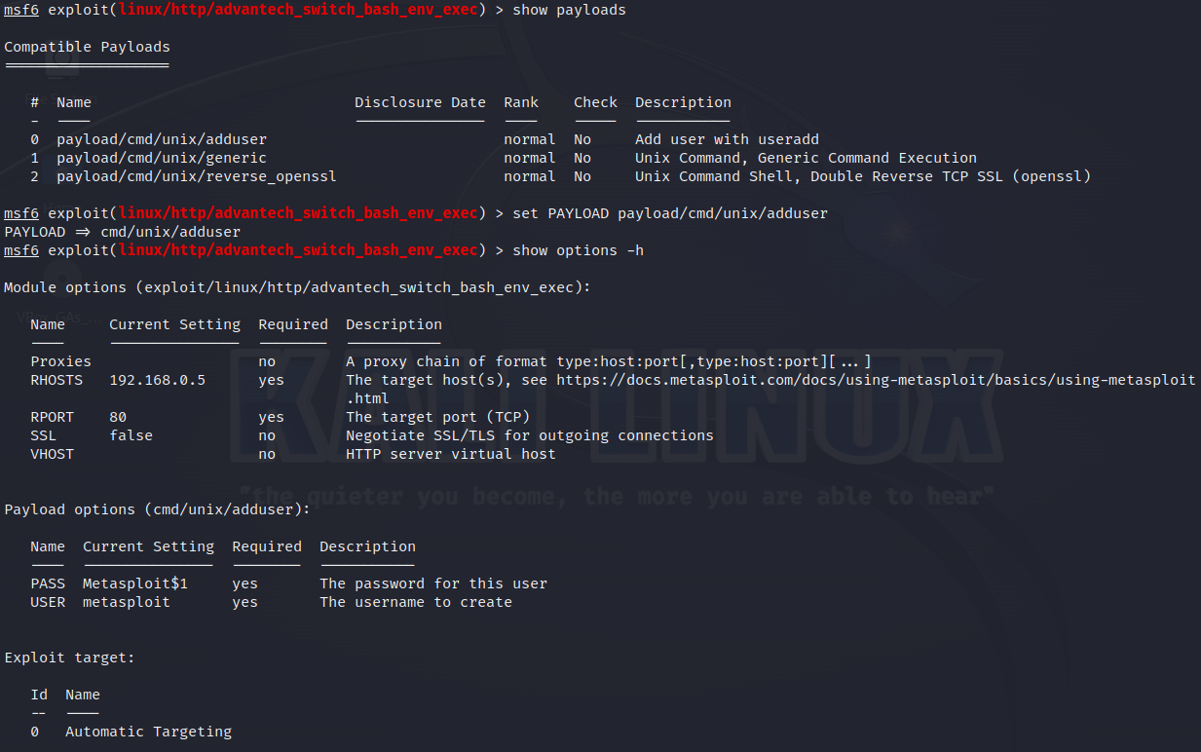

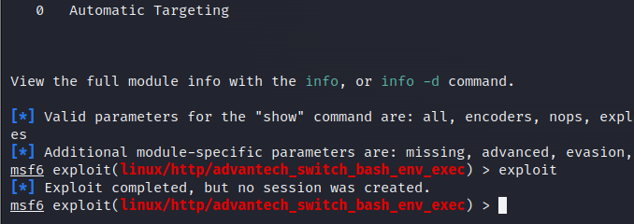

**2)ETERNALBLUE VULNERABILITY :**

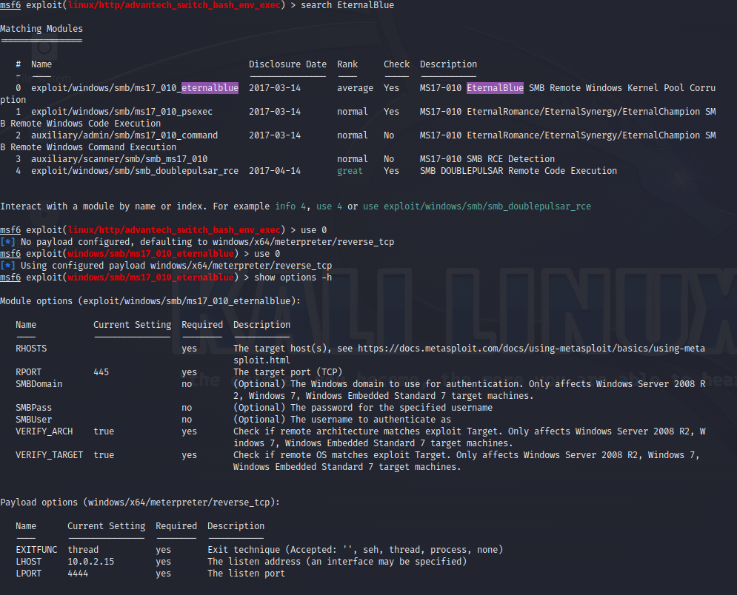

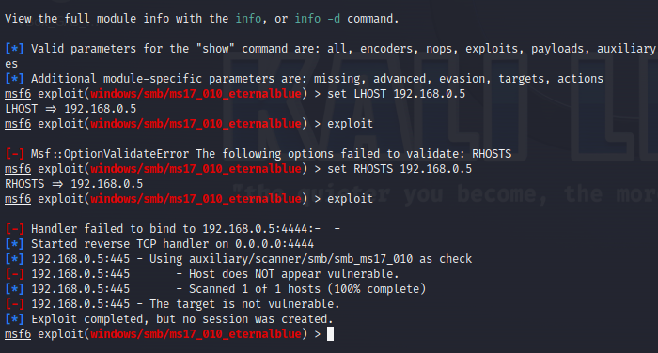

**3)Microsoft Exchange Server ProxyLogon Vulnerability :**

